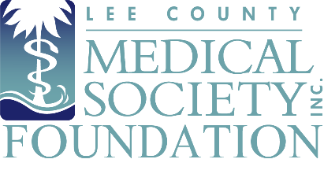
NEWS FOR IMMEDIATE RELEASE
Contact: Julie Ramirez, CAE, Executive Director
jramirez@lcmsfl.org
(239) 936-1645

Physician Wellness Program Receives Major Gifts

Fort Myers, FL (December 1, 2022) – Lee County Medical Society (LCMS) Foundation is proud to announce receipt of two large financial gifts that will help the Foundation expand its Physician Wellness Program (PWP) to combat physician burnout and provide confidential psychological counseling to LCMS physician members facing mental health challenges as a result of their front-line response work during Hurricane Ian. The gifts were provided by the Dade County Medical Association and FineMark National Bank & Trust.

“I’m so proud of my colleagues in medicine who continue to work tirelessly to aid and treat victims of Hurricane Ian,” said Tracy Vo, DO, President of Lee County Medical Society. “Many Society members suffered serious personal and professional property losses themselves during the storm. Along with disaster relief grants from Florida Medical Association, these community contributions to our Foundation will help them rebuild and provide additional counseling sessions to support their mental health recovery.”

The Foundation received $10,000 from FineMark National Bank & Trust within a few weeks of the storm and was recently presented with a check for $13,500 from Dade County Medical Association (photo). Additional financial gifts to the Foundation since the storm have been received from the Florida Medical Association Alliance; Hillsborough County Medical Association; Candice Barr, retired Executive Director of Lane County Medical Society, Oregon and Cheryl Malone, Executive Director of New York County Medical Society.

In October, Florida Medical Association’s Foundation for Healthy Floridians began offering Medical Disaster Relief grants to Lee County physicians whose practices were severely damaged or forced to temporarily close because of Hurricane Ian. Grants of up to $10,000 can be used to reopen/restore practices. Lee County physicians have until January 20, 2023, to apply for the grant.

Lee County Medical Society Foundation is the charitable arm of Lee County Medical Society, a professional organization of over 800 physician members practicing in Lee County, Florida. The Foundation supports the charitable efforts of physician members with an aim to improve the quality of life of its members and the public. Gifts to the Foundation fund the Physician Wellness Program, which provides free and confidential psychological counseling to physicians so they can address normal life difficulties, avoid burnout, and combat mental health trauma caused by Hurricane Ian. For more information, go to www.lcmsfl.org.

