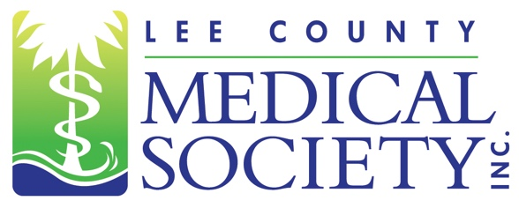
NEWS FOR IMMEDIATE RELEASE
Contact: Julie Ramirez, Executive Director
jramirez@lcmsfl.org
(239) 936-1645

Lee County Medical Society Installs 2023 Board of Directors

Fort Myers, FL (February 7, 2023) – The Lee County Medical Society (LCMS) is pleased to announce it officially installed its 2023 Board of Directors surrounded by LCMS members and guests on January 20, 2023. Newly inducted Board President Ryan Lundquist, MD, a radiologist at Radiology Regional, announced his presidential priorities for the upcoming year which will include expanding the Society’s member outreach, exploring more continuing education opportunities, and advocating for the mental health well-being of all healthcare providers in the area.

“I am excited to step into this role and use my voice to advocate for my fellow physicians and for our Lee County patients across the heath care continuum,” said Dr. Lundquist. “The health care community faced extreme challenges after Hurricane Ian, but these challenges can also be viewed as opportunities for improvement. Together, we can strengthen the first-line healthcare responder network to respond with even more synergy and collaboration.”

The 2023 LCMS Board of Directors Executive Committee is: President Ryan Lundquist, MD; President-elect Scott Caesar, MD; Treasurer Gamini Soori, MD; Secretary Arie Dosoretz, MD; and Past President Tracy Vo, DO.

LCMS would also like to recognize its 2023 Directors and Members at Large: Danielle Matta, DO; Ramon Pabalan, MD; Lucia Huffman, MD; Justin Casey, MD; Magali Van Den Bergh, MD; Liliana Bustamante, MD; and Ex Officio members: Stuart Bobman, MD; and Shane Geffe, MD. Also assisting the Board is Executive Director Julie Ramirez, CAE.

Lee County Medical Society is a professional organization of over 800 physician members practicing in Lee County, Florida. Its mission is to advocate for physicians and their relationships with patients; promote public health and uphold the professionalism of the practice of medicine. Since 1927, the Society has been a trusted source of health policy leadership in Lee County. The Society also provides programs to educate physicians of all specialty areas while encouraging professional integrity and unity. In 2020, the Society transitioned to a permanent virtual office. For more information, go to www.lcmsfl.org.

