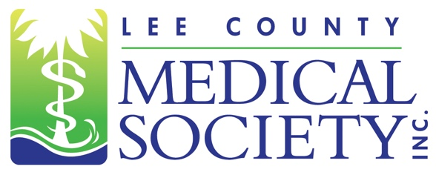
NEWS FOR IMMEDIATE RELEASE
Contact: Julie Ramirez, Executive Director
jramirez@lcmsfl.org
(239) 936-1645

Lee County Medical Society to Host Advanced Medical Provider Job Fair on April 20th at Collaboratory

Fort Myers, FL (March 13, 2024) – As part of its mission to promote public health and uphold the professionalism of the practice of medicine, Lee County Medical Society (LCMS) will host an Advanced Medical Provider Job Fair on Saturday, April 20, 2024, from 10:00 am to 2:00 pm at Collaboratory. This event will provide a safe and fair environment where advanced medical providers like Advanced Registered Nurse Practitioners, Physician Assistants, Nurse Practitioners, Anesthesiologist Assistants, and Certified Registered Nurse Anesthetists can meet and discuss career opportunities with Fort Myers-based physician practices, clinics, and facilities.

“Our area is continuing to grow at a very fast pace and our ability to provide quality medical care must meet this demand,” said LCMS President Scott Caesar, MD. “The job fair provides a venue through which all types of medical providers can share in this goal. Collectively, we want to create rewarding pathways for individuals with advanced medical skills who desire careers that contribute meaningfully to the well-being of our communities.”

Career-seeking individuals with advanced medical training or licensure can attend the job fair for free. They should bring resumes and proof of training certifications. LCMS member and non-member medical entities seeking to reserve a recruiting table at this event may secure participation at www.lcmsfl.org/jobboard.

ABOUT LCMS
Lee County Medical Society is a professional organization of over 800 physician members practicing in Lee County, Florida. Its mission is to advocate for physicians and their relationships with patients; promote public health and uphold the professionalism of the practice of medicine. Since 1927, the Society has been a trusted source of health policy leadership in Lee County. The Society also provides programs to educate physicians of all specialty areas while encouraging professional integrity and unity. In 2020, the Society transitioned to a permanent virtual office. For more information, go to www.lcmsfl.org.

